**Plugin Configuration**

Go to **Admin Panel >> MANAGE TAB >>** Click on **Ticket Details** Form Link.  
  
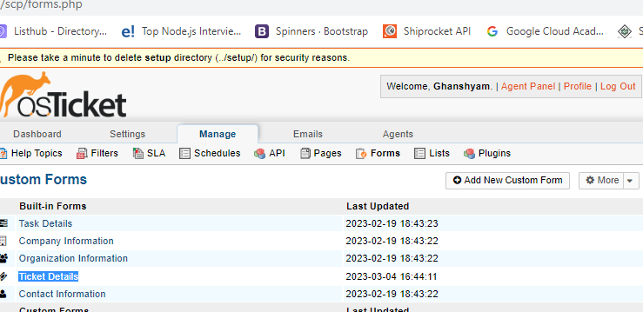  
  
Create **6 dynamics Fields** , Follow the configuration as in below Snap and make sure in response time configuration and **make sure in response time configuration , enable show time selection** , so that we can watch time difference.  
**IMPORTANT – VARIABLE Names should be defined same as snapshot.**  
  
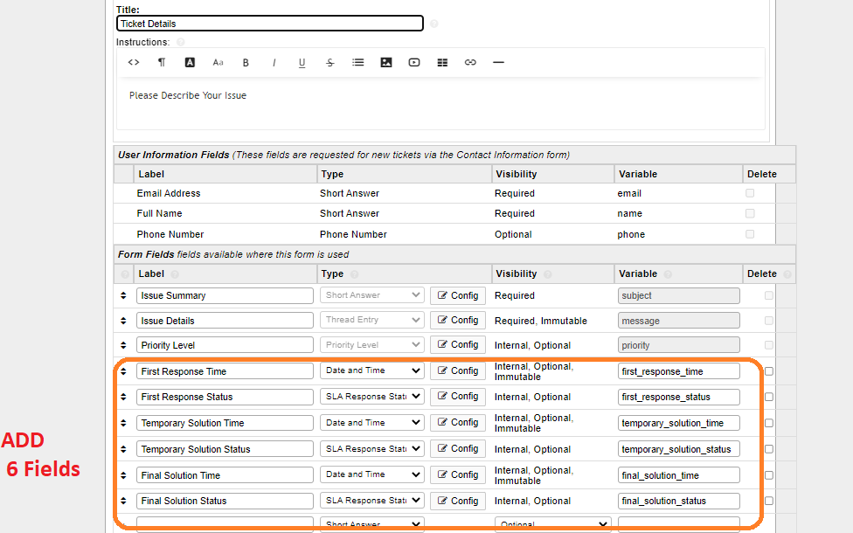  
  
**Please Configure Field settings as instructed in below Table.**

|  |  |  |  |  |
| --- | --- | --- | --- | --- |
| **Label** | **Type** | **Visibility** | | **Variable** |
|  |  | **Field Setup** | **Settings** |  |
| First Response Time | Date and Time |  |  | first_response_time |
| First Response Status | [SLA Response Status List](http://osticket-sla-test01.taxcore.dti.rs/scp/lists.php?id=2) |  |  | first_response_status |
| Temporary Solution Time | Date and Time | Same as First Response Time | Same as First Response Time | temporary_solution_time |
| Temporary Solution Status | [SLA Response Status List](http://osticket-sla-test01.taxcore.dti.rs/scp/lists.php?id=2) | Same as First Response **Status** | Same as First Response **Status** | temporary_solution_status |
| Final Solution Time | Date and Time | Same as First Response Time | Same as First Response Time | final_solution_time |
| Final Solution Status | [SLA Response Status List](http://osticket-sla-test01.taxcore.dti.rs/scp/lists.php?id=2) | Same as First Response **Status** | Same as First Response **Status** | final_solution_status |

**Fields configuration and settings for Time Fields (First Response Time , Temporary Solution Time , Final Solution Time are same).  
Fields configuration and settings for Status Fields (First Response Status, Temporary Solution Status, Final Solution Status are same).**

**Configuration Done .**

1. **Now** createa new ticket by selecting the sla plan accordingly and see the SLA pause feature by variation in Estimated due date on ticket details.  
   Here Agent can also see the response times and dates.

For example –

